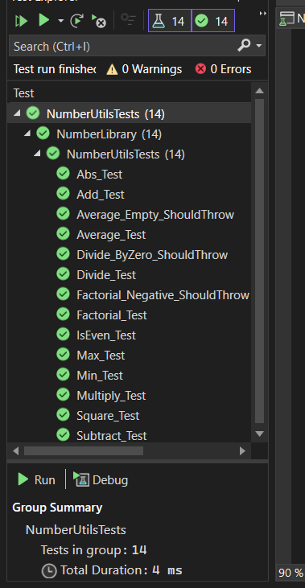

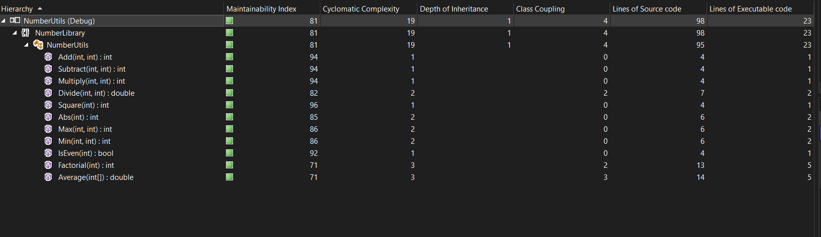

PS C:\Users\Asus2026\Desktop\Varga Kata\Unit teszt beadandó> dotnet test --collect:"XPlat Code Coverage"
Restore complete (1,3s)
NumberUtils succeeded (2,1s) → NumberUtils\bin\Debug\net8.0\NumberUtils.dll
NumberUtilsTests succeeded (2,0s) → NumberUtilTest\bin\Debug\net8.0\NumberUtilsTests.dll
[xUnit.net 00:00:00.00] xUnit.net VSTest Adapter v2.5.3.1+6b60a9e56a (64-bit .NET 8.0.20)
[xUnit.net 00:00:00.07] Discovering: NumberUtilsTests
[xUnit.net 00:00:00.10] Discovered: NumberUtilsTests
[xUnit.net 00:00:00.10] Starting: NumberUtilsTests
[xUnit.net 00:00:00.22] Finished: NumberUtilsTests
NumberUtilsTests test succeeded (2,5s)

Test summary: total: 14; failed: 0; succeeded: 14; skipped: 0; duration: 2,2s
Build succeeded in 9,1s

Workload updates are available. Run `dotnet workload list` for more information.

Attachments:
C:\Users\Asus2026\Desktop\Varga Kata\Unit teszt beadandó\NumberUtilTest\TestResults\043c4684-421f-4fd8-84b1-dd9c35f29db3\coverage.cobertura.xml

2026-03-18T12:43:20: Arguments
2026-03-18T12:43:20: -reports:
2026-03-18T12:43:20: NumberUtilsTests\TestResults\**\coverage.cobertura.xml
2026-03-18T12:43:20: -targetdir:coveragereport

